Web Development Research

How everyday choices affect the environment
- Recycling
- Public Transport
- Energy Use
- Avoid Fast Fashion
- Reduce food waste
How everyday choices affect the environment
- Recycling
  - Conserve resources (reduce, reuse, recycle)
    - Recycling paper and wood – saves trees and forests, trees can be regrown, but forests can’t be replaced
    - Recycling Plastic – Creating less new plastic
    - Recycling Metals – Less need for risky mining and extraction of new ores
    - Recycling glass – reduced the need to use new raw materials like sand. Sand supplies low
  - Save energy
    - Making products from recycled materials uses 95% less energy, for steel its around 70% less energy
    - Making paper from recycled materials uses 40% less energy
    - Recycling one glass bottle can save enough energy to to power a 100 watt bulb for 4 hours.
  - Less pollution
    - Since recycling uses less power, there is less need for power generation for this purpose reducing greenhouse gas emissions
  - Three R’s
    - Reduce – Use less stuff in the first place
    - Reuse – Reuse stuff before recycling to minimise waste
    - Recycle – If it can’t be reused, recycle so it can be used to make something new.
- Food Waste
  - Waste Natural Resources
    - Water – Agriculture uses 70% of the worlds water, By wasting food we waste water. There are countries around the world with water shortages, with some countries on the verge of becoming uninhabitable. We need to conserve water. (Movie Wall-e)
  - Climate Change
    - Methane – Food in landfill releases methane. Methane is 25x worse than CO2. When methane is released it lingers for 12 years. It contributes to 20% of greenhouse gas emissions. If food waste treatment is used, it would stop 11% of greenhouse gas emissions.
- Saving waste (What can we do)
  - This is using what we have, don’t buy more than you need!
  - Poor waste control causes a lot of methane gas, it is responsible for 30% of the methane gas that enters the atmosphere.
  - In the UK 44% of waste is recycled, which means 56% is not and ends up in landfill, Recyling more lowers this deficit
  - Good waste management leads to more recycling allowing more waste products to be reused. This has less impact than creating fresh material.
    - Less litter, nicer communities
    - Cleaner air, better QOL
    - Cheaper materials that are readily available for new products
    - More space in landfills for products that can’t be recycled.
How money, jobs and budgeting shape sustainable living
- Money
  - Personal Finance:
    - Conscience consumerism – When shopping having money means you can afford to vote with your wallet to support sustainable brands, buying local, and choosing durable brands over fast fashion.
      - Durable brands vs Fast Fashion
        - Durable brands often cost substantially more, even though they last longer it means if you don’t have much liquidity, you can’t invest in the more durable brand and fast fashion is more affordable at any given time with minimal saving. Example – Primark
    - Buying less and Reusing
      - Spend less and focus more on needs rather than wants, repairing items and buying second hand.
        - Second Hand
          - Second hand has a stigma but is a great way to give products new life with another owner while recouping some loss from the initial purchase.
          - Shop smart and there’s hidden gems for a great price, Facebook market place is a great example.
        - Repair Items
          - Instead of buying a new phone, take it to a repair shop and fix it. E-Waste is a huge issue of wants over needs and disposing of perfectly good devices because they want a new one. Evaluate whether you need a new one or want one.
    - Energy Efficient Upgrades
      - Money enables investment in energy efficient home improvement like solar panels, insulation and heat pumps which reduce carbon emissions and utility bills.
        - The caveat is to invest you need money to begin with, for many this isn’t an option with bigger bills and lower income.
- Jobs
  - Shifting to circular economy
    - Currently most jobs follow a Extract – Manufacturing – Disposal model. A circular economy promotes recycling: Extract – Manufacturing – Recycling – Extract etc.
  - Incorporating green skills everywhere
    - Jobs now require employees to bring sustainable thinking into everyday roles like finance, construction and marketing.
    - Instead of making a product via any means necessary, thinking from the start: is this able to be recycled, what materials to use etc.
  - Driving Innovation
    - Designing new, eco friendly systems and technologies that make products more eco friendly.
    - Examples of this innovation is Solar panels and wind turbines replacing coal power stations, Electric vehicles, Lab-grown leather, 3D printed meat.
  - The Trade-Offs
    - Green transition creates new jobs but destroys others – a wind turbine engineer may replace a coal miner, but not necessarily in the same place or for the same person.
    - Fossil fuel workers, fast fashion factory workers, and single-use plastics manufacturers all face job losses as industries transition – communities can be left behind.
    - Retraining for green skills costs money and time – not equally accessible to everyone.

Why balance and trade-offs matter
- Energy
  - Solar/wind is cleaner but requires land, wind farms vs. wildlife habitats, solar farms vs. farmland
  - Nuclear is low emission but produces radioactive waste
- Transport
  - Electric cars are greener to run but battery manufacturing is heavily polluting
  - Cycling is zero-emission but not realistic for everyone (distance, safety, disability)
- Food
  - Organic food is better for soil and biodiversity but uses more land and is more expensive
  - Local food has fewer food miles but seasonal limits reduce variety
  - Lab-grown/3D printed meat reduces livestock emissions but current production is energy-intensive and may be worse for the environment than pasture-raised beef
- Housing
  - Green building materials and insulation are better long-term but expensive upfront
  - Demolishing old inefficient buildings wastes the energy already spent constructing them
- Jobs and Economy
  - Closing a coal plant is good for emissions but can devastate the local community that depends on those jobs
  - Buying sustainably supports ethical brands but is inaccessible to people on low incomes
- Consumption
  - Second-hand shopping reduces waste but fast fashion keeps prices low for people who can’t afford alternatives
  - Repairing electronics is better than replacing but repair skills and services are disappearing

Sitemap:
Green City
│
├── Home
│├── The Mission
│ ├── What are the effects
│ ├── Test Your Knowledge
├── The Environment
│ ├── Why Protect the environment
│ ├── We can recycle
│ ├── We can protect natural resources
├── Your City
│ ├── How does your city affect the environment
│ ├── City Simulation – Demonstrate trade-offs
│
├── And You!
│ ├── Personal Finance
│ ├── Jobs & Careers
│ └── Budgeting
│
└── Quiz
Inspiration:
https://www.keepbritaintidy.org/eco-schools-environmental-education?gad_source=1&gad_campaignid=23586749179&gbraid=0AAAAADnaQhW2ERk-J5wPuqbZ6YvQ9g3GG&gclid=EAIaIQobChMIh8_s3a27kwMV_ZtQBh2QmznbEAAYASAAEgIbi_D_BwE
https://www.natgeokids.com/uk/
https://www.greenpeace.org.uk/resource-hub/education-resources/
https://www.nhm.ac.uk/

Wireframes:
Home Page:
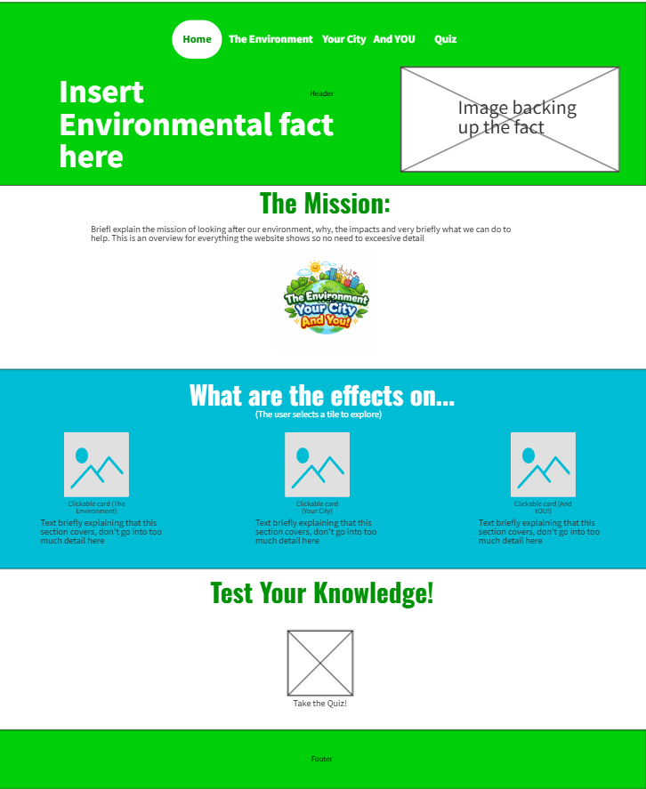
Environment Page:
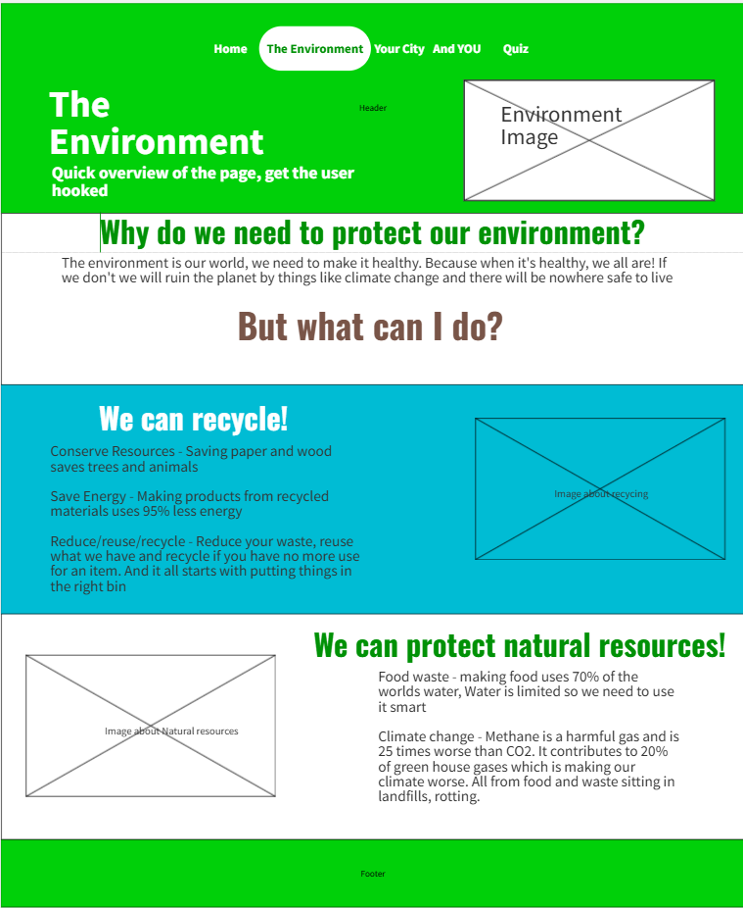

Your City Page:
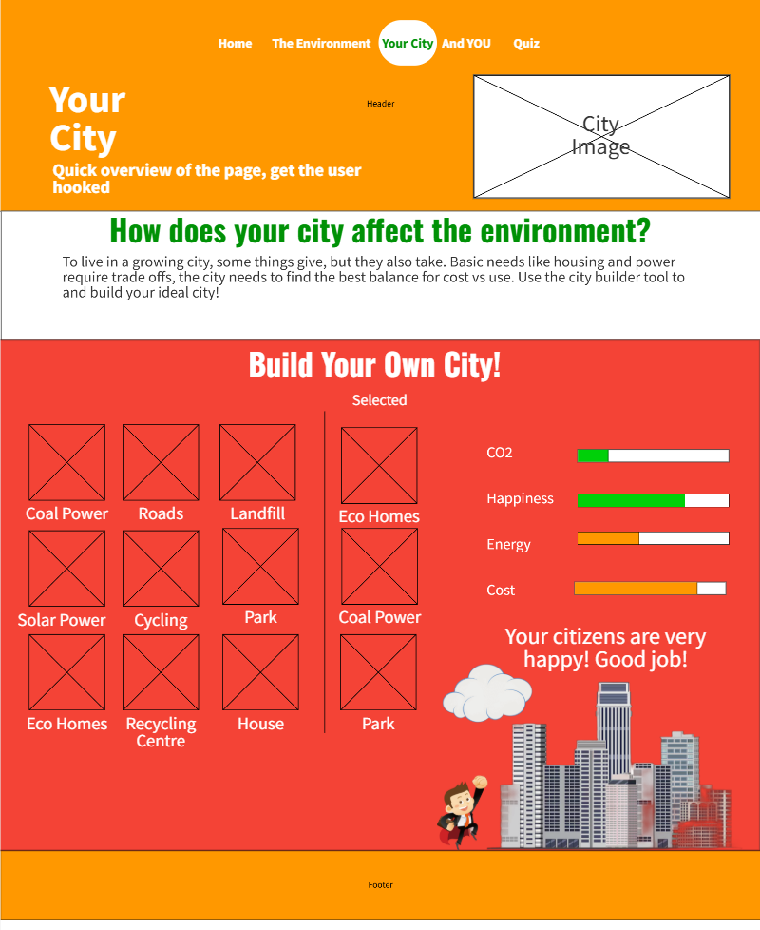
And you Page:
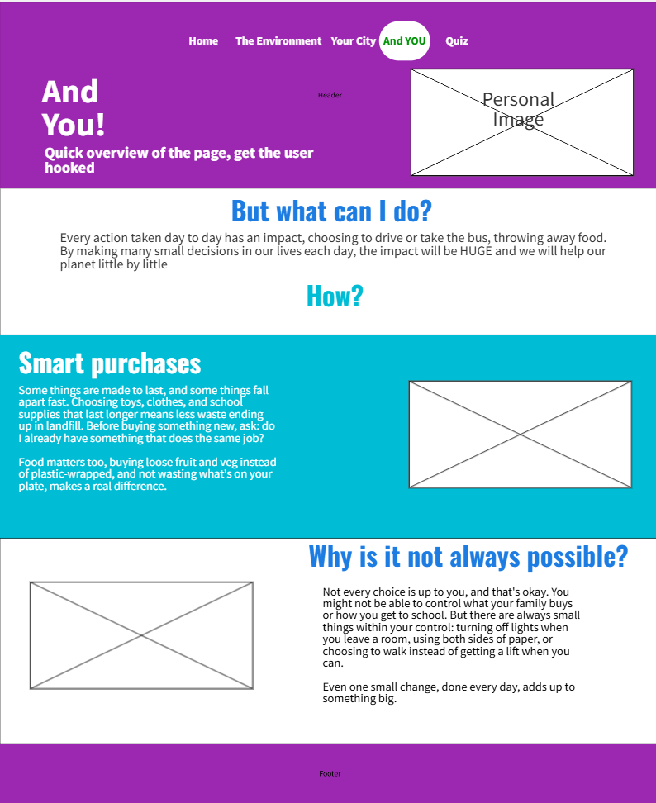
Quiz Page:


